**Object Oriented Programming**

**Computer System Engineering Department**

Sukkur Institute of Business Administration University

Mobile Shop

**LAB PROJECT REPORT**

SUBMITTED BY:

**NAME:** Tushar Kanjwani & Hammad ul Hassan & Taniraj Singh

**CMS ID:** 133-21-0009, 133-21-0007

Certificate

It is certified that Tushar Kanjwani & Hammad Ul Hassan & Taniraj a student of **BE-III** has carried out the necessary work of **Object Oriented Programming** as per course of studies prevailed at the Computer System Engineering Department, Sukkur Institute of Business Administration for **FALL-2022.**

Date: _______________ Instructor’s Signature

**ABSTRACT**

It is GUI based mobile shop program. In this program there is wide range of smart phones of different companies with different specifications and budget available for user. User can select any of this smart phone. When the user select a mobile from the given choices, specification of that mobile will be shown on screen along with the image of that smart phone. There are two buttons available right under specifications, Buy and close. If the user presses the close the button the window will be close. If the user presses the buy button a new window will be opened which will ask the user to enter his details for the customer receipt. When the user presses the submit button a thankyou message will be shown on screen and the window will be closed.

**FLOWCHART**

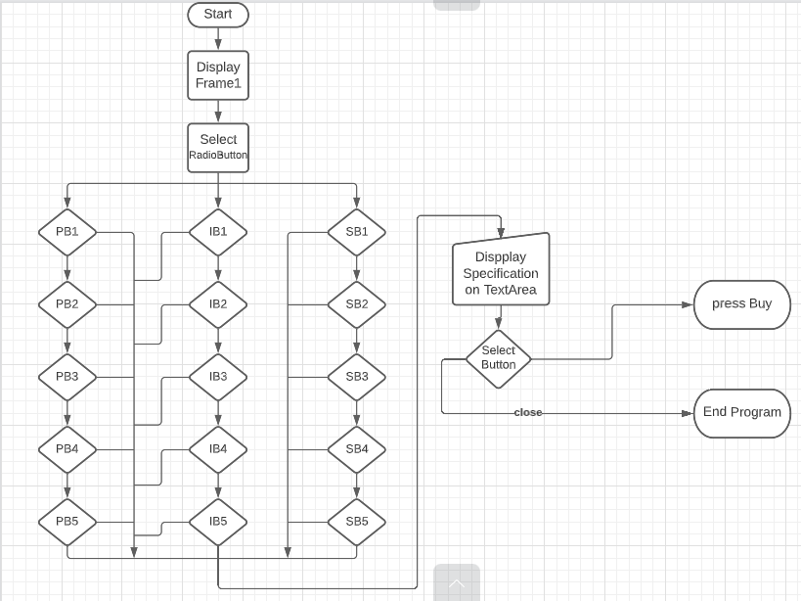

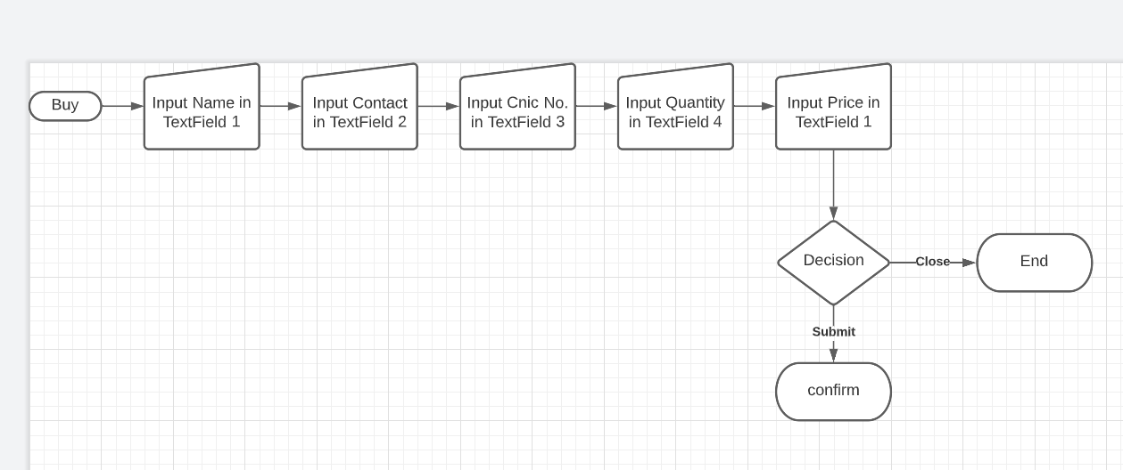

**IMPLEMENTATION OF JAVA**

**CODE:** SHOP.java File

package project;

import javax.swing.*;

import java.awt.*;

import java.awt.event.*;

import java.awt.event.ItemListener;

import java.io.*;

public class shop extends JFrame implements ActionListener{

JButton bPixel,bIphone,bSamsung,Buy,Cancel;

JTextArea screen;

JRadioButton r1,r2,r3,r4,r5,r6,r7,r8,r9,r10,r11,r12,r13,r14,r15;

JLabel lab,Price;

String x;

public shop(){

ButtonGroup bg=new ButtonGroup();

Font Fname = new Font("Times New Roman",Font.BOLD,40);

Font Fbutton = new Font("Times New Roman",Font.ROMAN_BASELINE,15);

Font Fname1 = new Font("Times New Roman",Font.BOLD,23);

Font Fdetail = new Font("Times New Roman",Font.ROMAN_BASELINE,20);

Font Fprice = new Font("Times New Roman",Font.BOLD,15);

JLabel Mname = new JLabel("SPECIFICATIONS");

JLabel name = new JLabel("Digital House");

lab = new JLabel("");

Price = new JLabel("");

bPixel = new JButton("Pixel");

bIphone = new JButton("Iphone");

bSamsung = new JButton("Samsung");

Buy = new JButton("Buy");

Cancel = new JButton("Close");

screen = new JTextArea();

r1=new JRadioButton("Pixel 7");

r2=new JRadioButton("Pixel 6");

r3=new JRadioButton("Pixel 5");

r4=new JRadioButton("Pixel 4");

r5=new JRadioButton("Pixel 3");

r6=new JRadioButton("I phone 14");

r7=new JRadioButton("I phone 13");

r8=new JRadioButton("I phone 12");

r9=new JRadioButton("I phone 11");

r10=new JRadioButton("I phone x");

r11=new JRadioButton("Galaxy S10");

r12=new JRadioButton("Galaxy S9");

r13=new JRadioButton("Galaxy J5");

r14=new JRadioButton("Galaxy J2");

r15=new JRadioButton("Galaxy A53");

name.setBackground(Color.LIGHT_GRAY);

Mname.setBackground(Color.LIGHT_GRAY);

name.setBounds(180, 30, 400, 50);

bPixel.setBounds(50,100,100,30);

bIphone.setBounds(250,100,100,30);

bSamsung.setBounds(450,100,100,30);

Buy.setBounds(300,510,100,30);

Cancel.setBounds(50,510,100,30);

Price.setBounds(420,500,140,30);

Mname.setBounds(50, 290, 300, 30);

screen.setBounds(50, 320, 350, 180);

lab.setBounds(410, 320, 150, 170);

r1.setBounds(50,130,100,30);

r2.setBounds(50,160,100,30);

r3.setBounds(50,190,100,30);

r4.setBounds(50,220,100,30);

r5.setBounds(50,250,100,30);

r6.setBounds(250,130,100,30);

r7.setBounds(250,160,100,30);

r8.setBounds(250,190,100,30);

r9.setBounds(250,220,100,30);

r10.setBounds(250,250,100,30);

r11.setBounds(450,130,100,30);

r12.setBounds(450,160,100,30);

r13.setBounds(450,190,100,30);

r14.setBounds(450,220,100,30);

r15.setBounds(450,250,100,30);

name.setFont(Fname);

bPixel.setFont(Fbutton);

bIphone.setFont(Fbutton);

bSamsung.setFont(Fbutton);

Buy.setFont(Fbutton);

Cancel.setFont(Fbutton);

Price.setFont(Fprice);

Mname.setFont(Fname1);

screen.setFont(Fdetail);

add(name);

add(bPixel);

add(bIphone);

add(bSamsung);

add(Buy);

add(Cancel);

add(Price);

add(Mname);

add(screen);

add(lab);

add(r1);

add(r2);

add(r3);

add(r4);

add(r5);

add(r6);

add(r7);

add(r8);

add(r9);

add(r10);

add(r11);

add(r12);

add(r13);

add(r14);

add(r15);

bg.add(r1);

bg.add(r2);

bg.add(r3);

bg.add(r4);

bg.add(r5);

bg.add(r6);

bg.add(r7);

bg.add(r8);

bg.add(r9);

bg.add(r10);

bg.add(r11);

bg.add(r12);

bg.add(r13);

bg.add(r14);

bg.add(r15);

r1.addActionListener(this);

r2.addActionListener(this);

r3.addActionListener(this);

r4.addActionListener(this);

r5.addActionListener(this);

r6.addActionListener(this);

r7.addActionListener(this);

r8.addActionListener(this);

r9.addActionListener(this);

r10.addActionListener(this);

r11.addActionListener(this);

r12.addActionListener(this);

r13.addActionListener(this);

r14.addActionListener(this);

r15.addActionListener(this);

setSize(600,600);

setLayout(null);

setTitle("Mobile Shop");

setVisible(true);

Buy.addActionListener(new ActionListener (){

public void actionPerformed(ActionEvent e){

setVisible(false);

NewClass info = new NewClass();

if(r1.isSelected()){NewClass.f9.setText(x);}

if(r2.isSelected()){NewClass.f9.setText(x);}

if(r3.isSelected()){NewClass.f9.setText(x);}

if(r4.isSelected()){NewClass.f9.setText(x);}

if(r5.isSelected()){NewClass.f9.setText(x);}

if(r6.isSelected()){NewClass.f9.setText(x);}

if(r7.isSelected()){NewClass.f9.setText(x);}

if(r8.isSelected()){NewClass.f9.setText(x);}

if(r9.isSelected()){NewClass.f9.setText(x);}

if(r10.isSelected()){NewClass.f9.setText(x);}

if(r11.isSelected()){NewClass.f9.setText(x);}

if(r12.isSelected()){NewClass.f9.setText(x);}

if(r13.isSelected()){NewClass.f9.setText(x);}

if(r14.isSelected()){NewClass.f9.setText(x);}

if(r15.isSelected()){NewClass.f9.setText(x);}}});

Cancel.addActionListener(new ActionListener (){public void actionPerformed(ActionEvent e){System.exit(0);}});

addWindowListener(new WindowAdapter(){public void windowClosing(WindowEvent e){dispose();}});

}

public void actionPerformed(ActionEvent e) {

if(r1.isSelected()){

screen.setText("\n Ram 4GB\n"

+" Memory 128GB\n"

+" Battery 3000mAh\n"

+" Front Camera \t4MP\n"

+" Main Camera \t8MP \n");

ImageIcon Pimage7 = new ImageIcon("D:\\pixel7.jpg");

lab.setIcon(Pimage7);

x = " 210,000/- PKR";

Price.setText(x);}

if(r2.isSelected()){

screen.setText("\n Ram 6GB\n"

+" Memory 128GB\n"

+" Battery 3500mAh\n"

+" Front Camera \t6MP\n"

+" Main Camera \t108MP \n");

ImageIcon pimage6 = new ImageIcon("D:\\pixel6.jpg");

lab.setIcon(pimage6);

x = " 170,000/- PKR";

Price.setText(x);}

if(r3.isSelected()){

screen.setText("\n Ram 8GB\n"

+" Memory 256GB\n"

+" Battery 3500mAh\n"

+" Front Camera \t8MP\n"

+" Main Camera \t12MP \n");

ImageIcon pimage5 = new ImageIcon("D:\\pixel5.jpg");

lab.setIcon(pimage5);

x=" 150,000/- PKR";

Price.setText(x);}

if(r4.isSelected()){

screen.setText("\n Ram 10GB\n"

+" Memory 256GB\n"

+" Battery 4000mAh\n"

+" Front Camera \t8MP\n"

+" Main Camera \t12MP \n");

ImageIcon pimage4 = new ImageIcon("D:\\Pixel4.jpg");

lab.setIcon(pimage4);

x= " 150,000/- PKR";

Price.setText(x);}

if(r5.isSelected()){

screen.setText("\n Ram 12GB\n"

+" Memory 512GB\n"

+" Battery 4500mAh\n"

+" Front Camera \t12MP\n"

+" Main Camera \t16MP \n");

ImageIcon pimage3 = new ImageIcon("D:\\pixel 3.jpg");

lab.setIcon(pimage3);

x=" 105,000/- PKR";

Price.setText(x);}

if(r6.isSelected()){

screen.setText("\n Ram 2GB\n"

+" Memory 64GB\n"

+" Battery 2500mAh\n"

+" Front Camera \t4MP\n"

+" Main Camera \t6MP \n");

ImageIcon Iimage1 = new ImageIcon("D:\\iphone14.jpg");

lab.setIcon(Iimage1);

x=" 350,000/- PKR";

Price.setText(x);}

if(r7.isSelected()){

screen.setText("\n Ram 4GB\n"

+" Memory 64GB\n"

+" Battery 3000mAh\n"

+" Front Camera \t6MP\n"

+" Main Camera \t8MP \n");

ImageIcon Iimage2 = new ImageIcon("D:\\iphone13.jpg");

lab.setIcon(Iimage2);

x=" 270,000/- PKR";

Price.setText(x);}

if(r8.isSelected()){

screen.setText("\n Ram 6GB\n"

+" Memory 128GB\n"

+" Battery 3500mAh\n"

+" Front Camera \t8MP\n"

+" Main Camera \t12MP \n");

ImageIcon Iimage3 = new ImageIcon("D:\\iphone12.jpg");

lab.setIcon(Iimage3);

x=" 210,000/- PKR";

Price.setText(x);}

if(r9.isSelected()){

screen.setText("\n Ram 8GB\n"

+" Memory 256GB\n"

+" Battery 4000mAh\n"

+" Front Camera \t12MP\n"

+" Main Camera \t16MP \n");

ImageIcon Iimage4 = new ImageIcon("D:\\iphone11.jpg");

lab.setIcon(Iimage4);

x=" 170,000/- PKR";

Price.setText(x);}

if(r10.isSelected()){

screen.setText("\n Ram 6GB\n"

+" Memory 512GB\n"

+" Battery 4000mAh\n"

+" Front Camera \t8MP\n"

+" Main Camera \t12MP \n");

ImageIcon Iimage5 = new ImageIcon("D:\\iphoneX.jpg");

lab.setIcon(Iimage5);

x=" 130,000/- PKR";

Price.setText(x);}

if(r11.isSelected()){

screen.setText("\n Ram 2GB\n"

+" Memory 16\n"

+" Battery 2500mAh\n"

+" Front Camera \t4MP\n"

+" Main Camera \t6MP \n");

ImageIcon Simage1 = new ImageIcon("D:\\galaxy s10.jpg");

lab.setIcon(Simage1);

x=" 220,000/- PKR";

Price.setText(x);}

if(r12.isSelected()){

screen.setText("\n Ram 4GB\n"

+" Memory 32GB\n"

+" Battery 3000mAh\n"

+" Front Camera \t6MP\n"

+" Main Camera \t8MP \n");

ImageIcon Simage2 = new ImageIcon("D:\\galaxy s9.jpg");

lab.setIcon(Simage2);

x=" 160,000/- PKR";

Price.setText(x);}

if(r13.isSelected()){

screen.setText("\n Ram 4GB\n"

+" Memory 64GB\n"

+" Battery 3000mAh\n"

+" Front Camera \t4MP\n"

+" Main Camera \t6MP \n");

ImageIcon Simage3 = new ImageIcon("D:\\galaxy j5.jpg");

lab.setIcon(Simage3);

x=" 21,000/- PKR";

Price.setText(x);}

if(r14.isSelected()){

screen.setText("\n Ram 6GB\n"

+" Memory 256GB\n"

+" Battery 3500mAh\n"

+" Front Camera \t8MP\n"

+" Main Camera \t12MP \n");

ImageIcon Simage4 = new ImageIcon("D:\\galaxyj2.jpg");

lab.setIcon(Simage4);

x=" 10,000/- PKR";

Price.setText(x);}

if(r15.isSelected()){

screen.setText("\n Ram 8GB\n"

+" Memory 512GB\n"

+" Battery 5000mAh\n"

+" Front Camera \t12MP\n"

+" Main Camera \t16MP \n");

ImageIcon Simage5 = new ImageIcon("D:\\galaxy a53.jpg");

lab.setIcon(Simage5);

x=" 35,000/- PKR";

Price.setText(x);}

if(e.getSource()==Cancel){screen.setText(" ");}}

public static void main(String[] args) {

shop obj = new shop();}

}

info.java File

package project;

import javax.swing.*;

import java.awt.*;

import java.awt.Dimension;

import java.awt.Toolkit;

import java.awt.event.*;

public class NewClass extends JFrame implements ActionListener{

JButton submit,close;

static JTextField f9,f5;

public NewClass(){

Font myfont1 = new Font("Times New Roman",Font.BOLD,16);

Font myfont = new Font("Times New Roman",Font.BOLD,14);

Label l=new Label("RECEIPT INFORMATION");

Label l5=new Label("NAME");

Label l6=new Label("CONTACT");

Label l7=new Label("CNIC No.");

Label l8=new Label("QUANITITY");

Label l9=new Label("PRICE");

JTextField f6=new JTextField();

JTextField f7=new JTextField();

JTextField f8=new JTextField();

f5=new JTextField();

f9=new JTextField();

submit=new JButton("Submit");

close=new JButton("Close");

l.setBounds(70,50,250, 30);

l5.setBounds(40,95,70, 30);

l6.setBounds(40, 145, 70, 30);

l7.setBounds(40,195,70, 30);

l8.setBounds(40,245,90, 30);

l9.setBounds(40,295,70, 30);

f5.setBounds(140,95,150, 30);

f6.setBounds(140, 145, 150, 30);

f7.setBounds(140, 195, 150, 30);

f8.setBounds(140,245,150, 30);

f9.setBounds(140,295,150, 30);

submit.setBounds(230,385,100, 30);

close.setBounds(230,350,100, 30);

l.setFont(myfont1);

l5.setFont(myfont);

l6.setFont(myfont);

l7.setFont(myfont);

l8.setFont(myfont);

l9.setFont(myfont);

submit.setFont(myfont);

close.setFont(myfont);

add(l);

add(l5);

add(l6);

add(l7);

add(l8);

add(l9);

add(f5);

add(f6);

add(f7);

add(f8);

add(f9);

add(submit);

add(close);

submit.addActionListener(this);

Image image=Toolkit.getDefaultToolkit().getImage("C:\\IBA.JPG");

close.addActionListener(new ActionListener (){public void actionPerformed(ActionEvent e){System.exit(0);}});

setSize(350,450);

setLayout(null);

setTitle("personal information");

setVisible(true);

setIconImage(image);

setResizable(false);

}

public void actionPerformed(ActionEvent e){

if(e.getSource()== submit){

JOptionPane.showMessageDialog(this,"ThankYou "+f5.getText()+", for Shopping");System.exit(0);

}}}

**OUTPUT:**

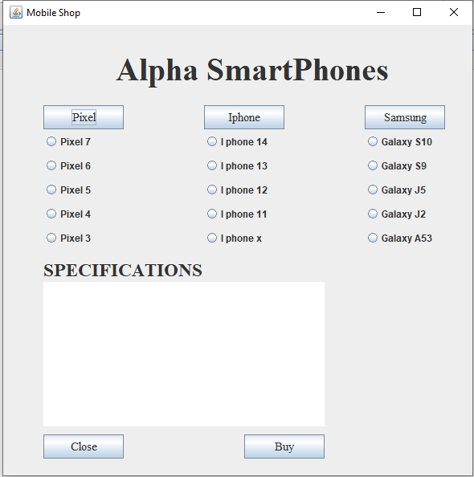

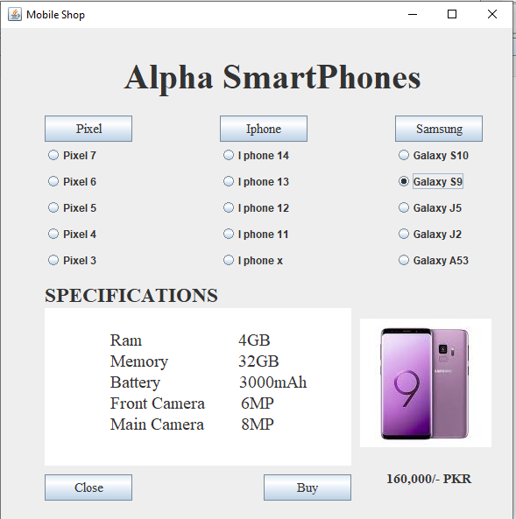

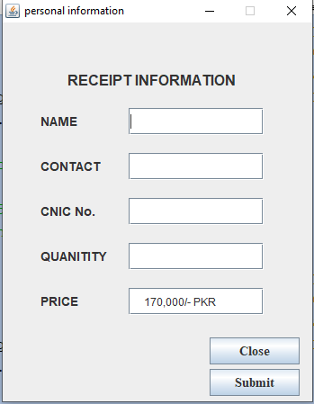

**CONCLUSION**

The main purpose of this project was to enhance the programming skills in java through making a project from the knowledge which we gain from this course. Also this project has a real life application and can be used by the mobile shop owners to convert their shop from physical to digital. User can compare different smartphones specs and budget and can buy the best one for himself while sitting at home or somewhere else. It will made the life easier for buyer. He won’t have to go to a shop to buy a smartphone.